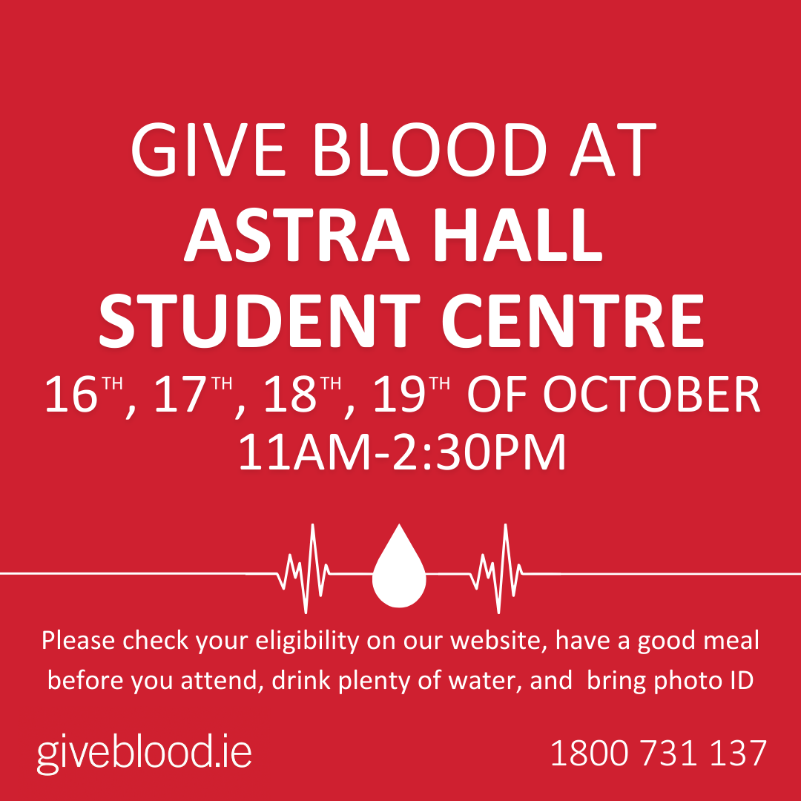

GIVE BLOOD

SAVE LIVES

CLINIC LOCATION  
DATES  
TIMES