2025
Irish Blood Transfusion Service
IBTS Climate Action Roadmap
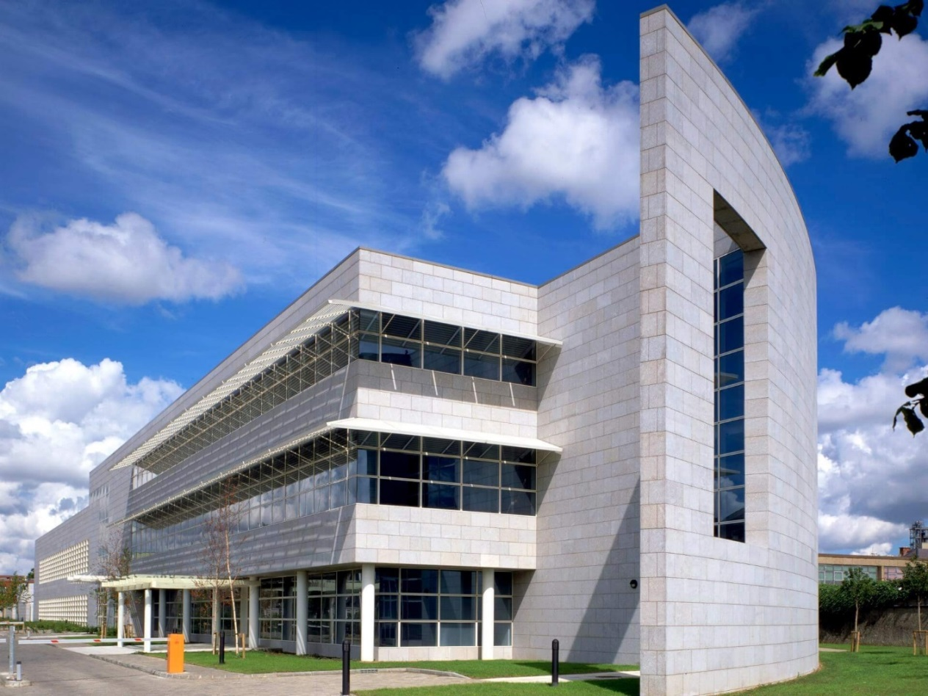
Contents
Page 2 - Glossary of Terminology
Page 3 – Introduction to the IBTS and the Climate Action Mandate
Page 4 – Section 1: Our Targets
Page 4 – 1.01 Mandated Targets for the IBTS
Page 5 – 1.02 Current State of Play (FY2024) for the IBTS Emission Sources
Page 11 – 1.03 Energy Audit & Implementation of the RoO
Page 12 – 1.04 Projects Included for 2025 (Complete, In Progress, and Planned)
Page 14 – 1.05 Projects Included for 2026 (Planned & Potential Opportunities)
Page 16 – 1.06 Projects Included for 2027 (Planned & Potential Opportunities)
Page 17 – 1.07 Projects Included for 2028 (Planned & Potential Opportunities)
Page 18 – 1.08 Projects Included for 2029 (Planned & Potential Opportunities)
Page 19 – 1.09 Projects Included for 2030 (Planned & Potential Opportunities)
Page 20 – 1.10 Gap to Target with Projects Assigned
Page 22 – 1.11 Energy Efficiency in the IBTS
Page 23 – Section 2: Our People
Page 23 – 2.01 Leadership & Governance
Page 23 – 2.02 Sustainability Steering Group (SSG)
Page 24 – 2.03 Engagement
Page 24 – 2.04 Staff Training
Page 26 - Section 3: Our Way of Working
Page 26 - 3.01 Energy & Environmental Management Systems and Accreditation
Page 26 – 3.02 Green Public Procurement (GPP)
Page 27 – 3.03 Training & Awareness
Page 28 – 3.04 Construction
Page 28 – 3.05 Homeworking
Page 28 – 3.06 Projects
Page 29 – 3.07 My Green Labs (MGL)
Page 29 – 3.08 Resource Management
Page 33 – Section 4: Our Buildings & Our Vehicles
Page 33 – 4.01 Our Buildings
Page 34 – 4.02 Our Vehicles
Page 38 – Conclusion
Page 39 – Appendix
Glossary of Terminology
- AHU – Air handling unit
- BAU – Business as usual
- BMS – Building Management System
- CAM – Climate Action Mandate (Declaration within the CAP of targets set out for the reduction of emissions)
- CAP – Climate Action Plan (Several annual publications by the Irish Government)
- CAR – Climate Action Roadmap
- CO₂ – Carbon Dioxide
- CO₂eq – Carbon Dioxide equivalent
- CPD – Continuous Professional Development
- EE Baseline – Energy Efficiency baseline for Public Sector targets – 2006-2008 averaged.
- EED – Energy Efficiency Directive
- EnPI – Energy Performance Indicator
- EOL – End-of-life
- EPA – Environmental Protection Agency
- EPBD – Energy Performance of Buildings Directive
- EPO – Energy Performance Officer
- EPR – Extended Producer Responsibility- Initiative to minimise waste production by promoting take back by the producer
- ESG – Environmental, Social, & Governance
- EV – Electric Vehicle
- EWC – European Waste Code (6-digit waste code for determination)
- FF – Fossil Fuel
- GHG - Greenhouse Gas
- GHG Baseline – Greenhouse Gas baseline for Public Sector targets – 2016-2018 averaged.
- GMP – Good Manufacturing Practice standards
- GPP – Green Public Procurement
- GTT – Gap to Target (Difference between projected emissions and energy use and targets)
- GTT Tool – Modelling tool for calculating and projecting future energy use and emissions
- HVO – Hydrotreated vegetable oil
- IBTS – Irish Blood Transfusion Service
- LED – Light Emitting Diode (a low energy use light source)
- LMS – Learning Management System
- M & R – Monitoring & Reporting (SEAI system)
- MGL – My Green Labs (Accreditation)
- NZEB – Nearly Zero Energy Building (Standard)
- RoO – Register of Opportunities (list of recommendations after an audit to be implemented which will have an impact on energy management within the organisation)
- SDG – Sustainable Development Goals
- SEAI – Sustainable Energy Authority of Ireland
- SEU – Significant Energy User
- SSG – Sustainability Steering Group
- S.I. 426/2014 – Statutory Instrument by the Irish Government which sets out the strategy to reduce emissions from energy sources and increase efficiency.
- S.I. 381/2021 – Statutory Instrument by the Irish Government which sets out the requirement for the purchase of ‘Clean’ Vehicles to aid in the reduction of Transport related emissions.
- TOR – Terms of Reference
- WEEE - Waste from Electrical and Electronic Equipment
- YOY – Year on year
Introduction to the IBTS and the Climate Action Mandate
The IBTS is a statutory body with responsibility for the national blood supply, and provides testing and tissue services to hospital, and is responsible for the Irish Unrelated Bone Marrow Registry. The main source for activity and energy use within the IBTS is the National Blood Centre in Dublin, with 2 other fixed clinics in Dublin (D’Olier Street & Stillorgan), 1 regional centre in Cork, and 1 site in each of Ardee, Carlow, Limerick, and Tuam that operate mobile clinics, along with our fleet for collection and transportation of blood.
The Public Sector Climate Action Mandate (CAM) was published in its most up-to-date format in 2025, in the Government’s Climate Action Plan (CAP) 2025. We have increased our compliance level relative to these requirements and are actively engaged in further increasing the Mandate’s implementation.
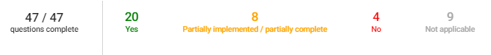
Figure 1 - IBTS responses to the 2024 Climate Action Mandate.
As a Public Body, the IBTS is mandated to comply with the Government’s target to reduce Ireland’s greenhouse gas (GHG) emissions by 51% by 2030, along with adhering to the European Union (Energy Efficiency) Regulations 2014, which will be referred to as S.I. 426/2014. S.I. 426 sets out reporting requirements on energy use and efficiency, and the information is reported on annually as part of the Sustainable Energy Authority of Ireland (SEAI) Monitoring & Reporting (M&R) programme.
As the IBTS operates as a unique body within the Public Sector, we must strive to both set the standard for the achievement of targets for ourselves, and to assess our performance relative to other operators within the Health Departmental Group. With Health making up 18% of the total final energy consumption of the Public Sector, it is important that management is in place to increase efficiency and reduce emissions overall.
To set out a strategy to achieve the targets we are mandated to meet, the IBTS lays out this Climate Action Roadmap (CAR), which will outline the current position relative to the targets, the achievements made thus far, and the planned future projects in place to achieve the targets, by 2030.
The CAR will be reviewed and updated regularly, and within 6 months of any update to the CAP, accounting for any changes in the CAM and any additional guidance published by SEAI.
With the development of our Climate Action Roadmap, the IBTS is stating that it will perform all functions in a manner consistent with Ireland’s climate ambitions. In addition to the Climate Action Roadmap, the IBTS developed a Sustainability Strategy for 2025-2030, aligning the objectives of the Climate Action Roadmap and expanding the view to assess other impacts within the organisation.

Section 1: Our Targets
1.01 Mandated Targets for the IBTS
The Government’s CAP sets out a number of both qualitative and quantitative targets to be achieved by the public sector, and the IBTS will strive to play our role in achieving them. The primary reported targets for the IBTS as with all Public Bodies are listed below:
- 51% reduction in fossil (thermal and transport) related GHG emissions
  - This includes an absolute reduction in heating and transport GHG emissions to ensure that fossil fuel use is reduced across the public sector.
  - For the IBTS, we are required to reduce these emissions from a 1,189 tonnes CO₂eq baseline to 583 tonnes CO₂eq in 2030.

- 51% reduction in energy related GHG emissions
  - This includes an absolute reduction in energy related GHG emissions (electricity, transport, and heating) sourced from buildings or vehicles that are owned or leased by the IBTS.
  - For the IBTS, we are required to reduce these emissions from a 3,204 tonnes CO₂eq baseline to 1,013 tonnes CO₂eq in 2030.

- 50% improvement in energy efficiency based on the 2006-2008 baseline data.
  - Energy efficiency upgrades assist in achieving this by reducing energy use relative to the floor space of the estate.

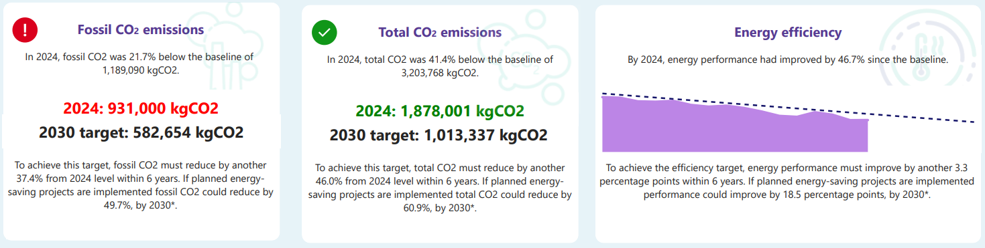
Figure 2 – Current performance (2024 data) for the IBTS against the mandated emissions and energy efficiency targets. The Fossil CO₂ emissions infographic highlights that additional work is required to meet the target, however the Total CO₂ and Energy Efficiency targets are on track to be delivered by 2030.
The IBTS uses fossil fuels in the buildings within the estate (natural gas & generator diesel), and for the transport fleet (road diesel).
Electricity is used within the estate also for various functions in the office based and laboratory settings; most of the grid electricity is currently sourced from fossil fuel (FF) power stations.
These energy sources generate GHG emissions, and these emissions are targeted by the CAM and the pathway to achieve this is laid out in this document.
While the IBTS does generate emissions through our activities, the scale of these activities and the nature of the organisation would not have any major impact in the implementation of the Government’s Climate Action Plan, Public Sector Climate Action Strategy, or the National Climate Action Strategy. We will also commit to publicly report on our climate action activities within our Annual Report, as directed within the Climate Action Mandate.
We are committed to addressing our impacts in line with the strategies laid out for Public Bodies in Ireland and meeting the ambitious targets set, aligned with Section 15 (1) of the Climate Action and Low Carbon Act.
There are new targets related to annual reduction of absolute energy consumption within public bodies, from the Energy Efficiency Directive (EED) and Energy Performance of Buildings Directive (EPBD), which are incorporated in the methodology for developing a project pipeline.

1.02 Current State of Play (FY2024) for the IBTS Emission Sources
1.02.01 Introduction

Figure 3 – Change in IBTS emissions by source from the GHG Baseline to 2024. The IBTS has made reduction in all 3 major emission sources.
There has been significant progress since the baseline period of 2016-2018 in terms of in-target emissions reduction across the Thermal, Transport, and Electricity emissions categories. The key to managing the reduction is an approach that tackles all the emission sources rather than limiting the focus to one impact.
The baseline period across the categories was 3,204 tonnes of CO₂eq, and the current period stands at 1,878 tonnes of CO₂eq, equating to a reduction in total emissions of 41%. There have been internal factors due to efficiency upgrades and changes in equipment which has aided this, and external forces which assisted this emissions reduction, mainly the decarbonisation of the electricity grid, and changes due to temperature shifts in 2024. Each of the 3 emission categories will be assessed individually below.

Figure 4 – The breakdown of the emissions by source in IBTS operations in 2024.

1.02.02 In-Target Electricity Emissions: Electricity
Electricity is a vital energy source across the IBTS; especially when considering the type of equipment in use to establish and maintain the laboratory set up at the Good Manufacturing Practice (GMP) standards. This includes the year-round use of chillers, low temperature freezers, and other significant energy user (SEU) activities and equipment.
For the emissions calculation purposes of the electricity used on site, the national average emissions for electricity produced is used, which has varied greatly, with a large downtrend in recent years, due to increase grid decarbonisation with renewable projects brought on-stream.
From the baseline period of 2016-2018, from the SEAI M&R System to now (2024), the electricity emissions for the whole IBTS have reduced from 2,015 tonnes of CO₂eq to 947 tonnes of CO₂eq. This was assisted by grid decarbonisation through increased renewables being brought on stream, however we had implemented several projects up to the end of 2024 that assisted with the reduction of electrical energy use:
- In 2022 it was identified through an infrared study of the heating system of the National Blood Centre, a loss or wastage of energy: a valve in an air handling unit which ran 24/7 was letting heating through it continuously (which then had to be compensated for through additional cooling with chilled water).
- The NBC (our primary SEU) received energy sub-metering installation and a BMS upgrade, which allows for regular monitoring of energy use, and the opportunity to identify issues prior to billing reports.
- The advent of homeworking for staff on a partial basis since the COVID pandemic has taken electricity usage out of the office and allowed staff to work from home.
- Greater awareness and education to staff about the impact of the systems in use and the energy and carbon associated with the use of such systems, there is a module on energy and environmental impacts offered to all new staff upon induction, added in 2024, which is now paired with the bespoke e-learning course offering for staff in 2025.
There has been absolute electrical energy reduction across the organisation of 22.8% since the GHG baseline, and a reduction of electrical energy YOY (2023-2024) of 3.1%, showing that we are making significant ongoing progress. Table 1 highlights the grid side decarbonisation also, as the 22.8% energy reduction, has coincided with a 53.0% emissions reduction.
Factor | GHG Baseline | 2019 | 2020 | 2021 | 2022 | 2023 | 2024
Electrical Energy (kWh) | 4,634,332 | 4,220,597 | 4,108,375 | 4,180,236 | 4,038,441 | 3,692,795 | 3,578,467
Electrical Emissions (tCO2eq) | 2,015 | 1,402 | 1,223 | 1,492 | 1,322 | 1,021 | 947
Table 1 - Change in electrical energy and emissions from that source from the GHG baseline to 2024.

1.02.03 In-Target Fossil Emissions: Thermal
As previously detailed, the emissions assigned to thermal emissions for the IBTS are mostly attributed to natural gas in our buildings. Savings to date associated with thermal emissions have been significant, with the 2016-2018 baselines of 942 tonnes of CO₂eq attributed to natural gas and generator diesel, having fallen by 21.2% to the 2024 value of 742 tonnes of CO₂eq. The 2024 value for this category is up 10.4% YOY, which is attributable to 2 main factors:
- A relatively cooler year in 2024 compared to previous years, especially in the summer, resulted in ongoing annual heating in our buildings, which was especially difficult in the NBC, which, now running on 2 end-of-life (EOL) boilers instead of 3, resulted in a high volume of additional natural gas usage, however, this was viewed as an anomaly, and projects to follow will address this.
- Additionally, we previously were not accounting for generator diesel, which is now included in our calculations, previous years were estimated based on SOPs for tests, however in 2024 there were 2 required extensive runs for maintenance, which gives an implied increase in use.
On site production of heat is mostly attributable to the use of natural gas within the IBTS estate, however there is still a high usage of natural gas even during the summer months, as seen in Fig. 5. This is due to the demand for hot water, heat exchange for the GMP lab settings, and also due to the overall inefficiencies of the in place boilers, and addressing these areas will be part of the improvements within the project pipeline.
While we did have an increase YOY for 2024, previously we had made improvements to the management of fossil fuel use in the buildings:
- As part of our Reduce Your Use focus, the organisation decided to invest in IBTS branded warm fleeces for staff, to ensure that energy use can be managed, and staff are comfortable.
- The previously noted impact from the HVAC running constantly due to a valve issue would have had a dual impact on electrical emissions, due to the required cooling, and the emissions due to the wastage of heat, generating increased thermal emissions.
- Additional savings were made when the 3 gas boilers were assessed and it was identified that there was major wastage due to 1 boiler being inefficient to the point that the remaining 2 boilers could meet the demand for the building in the National Blood Centre.

Figure 5 – The tracked natural gas use plotted against heating degree days (HDD) at the NBC, it can be noted that there is high baseline usage due to the inefficient boilers.

1.02.04 In-Target Fossil Emissions: Transport
Transport fuels are a major source of emissions for the IBTS and are emitted when burning fossil fuels in our fleet vehicles (owned or leased). The fuel used within the fleet is road diesel, and the operation of fleet vehicles include the use of restricted fuel cards to only use diesel for control of emissions and guarantee of fuel source.
In 2025, the Government declared that Ireland deployed 8.695% biodiesel in its fuel supply, with this number expected to grow over time, and this offsets emissions from fuels sourced at forecourts. This has resulted in a more efficient fuel at source being used within our fleet, however we are also working to directly reduce our impacts and have been successful in doing so.
With regards to the actual fuel use in the IBTS, we have achieved a reduction from 247 tonnes of CO₂eq at the baseline, to 189 tonnes of CO₂eq in the year ending 2024. This represents a 23% reduction in transport emissions from the baseline, and an 8% reduction YOY (2023-2024).
This has coincided with a change to newer, more fuel-efficient vehicles, and assisted by the increase in biodiesel added to the diesel stock as previously mentioned, has led to a reduction in emissions.
As part of the upgrades within the transport department, there was a move to upgrade the fleet used by the IBTS for the collection and transport of product. Road transport remains a vital part of Business-as-Usual (BAU) activities for the IBTS to assist in the collection, transport, and storage of the blood donated across the country and processing at our central location at the National Blood Centre.

Figure 6 – This highlights the change in fuel use in the IBTS from the GHG baseline to 2024. There has been significant progress in reducing the use of fuel in our fleet and emissions have reduced at an even greater level due to the introduction of biofuels into forecourt fuels.

1.02.05 Gap to Target (GTT) Under BAU to 2030
Under a BAU circumstance, projected forward to 2030, based on the data available for the IBTS for the end of 2024, we would not meet our targets, as can be seen in Figure 7 below.
Figure 7 – Sourced from the SEAI M&R GTT tool, this figure highlights the position the IBTS would be in if no projects were introduced to our operations from the end of 2024 to 2030
Due to this GTT, we require a major overhaul to our operations, and deciding on the project pathway to achieving this, required a detailed SI: 426 Energy Audit.
1.03 Energy Audit & Implementation of the Register of Opportunities (RoO)
1.03.01 Audit Process
In accordance with the requirements set out in the Climate Action Mandate, the IBTS was required to have undertaken, an Energy Audit in line with SI: 426. This audit was conducted by EnerJ in 2024.
In the initial assessment of the IBTS across the 8 buildings within the estate, it was determined that, as the National Blood Centre accounted for 92% of the building energy consumption, the audit would focus on the NBC, as any energy upgrades would have a greater impact on the total energy and carbon targets for the IBTS.
The assessment was made based on available data between January 2022 and December 2023, to understand trends in electricity and natural gas usage within the building.
The energy audit was carried out, where practical, in accordance with I.E. EN 16247 Parts 1 and 2 or ISO: 50002. The thoroughness is enough to be considered an investment grade energy audit. This audit meets the SEAI minimum criteria for energy audits as per European Union (Energy Efficiency) Regulations 2014 (SI 426 of 2014), as amended by SI 646 of 2016 and SI 599 of 2019.
The audit assessed the energy use within the IBTS and assessed the potential for future structural, equipment, and behavioural changes that would be required to be assigned to help the IBTS in meeting the Climate Action Mandated targets for energy and carbon emissions reduction.
The Register of Opportunities presented by EnerJ can be seen below in Fig. 8. The applicability of these have been assessed by the Climate and Sustainability Lead and the Facilities Team, to be integrated into the IBTS Climate Action Roadmap, and this is covered in Section 1.4.
1.03.02 Register of Opportunities
See Appendix Item 1.
1.03.03 Development of Project Pipeline
The approach taken by the IBTS, based on the recommendations from the energy audit conducted by EnerJ, is to assess the Climate Action Roadmap in 2 phases, with phase 1 from 2024-27 and phase 2 from 2028-30.
While we consider the 2 phases as separate, this is only in the approach that we make for the projects considered. The initial phase will deal with outstanding required upgrades to ensure continuity of service while making efficiency upgrades, and the following phase, will be to rectify any remaining Gap to Target, making informed decisions following on from the data gathered in phase 1, and may involve greater engineering changes and challenges to ensure existing building fabric & systems are adaptable to any future retrofitting projects.
It should be noted that the following upgrades mainly cover the National Blood Centre, which represents over 92% of the building energy use within the IBTS. While some projects will address the impacts of our other sites, much of the savings in the additional sites would have a negligible impact on the mandated targets, and on-going efficiency changes will occur in those sites.

1.04 Projects Included for 2025 (Complete, In Progress, and Planned)
1.04.01 LED Light Upgrade and Smart Lighting System
One of the most obvious upgrades to be undertaken is the conversion of lighting systems in the National Blood Centre from fluorescent lighting to LED lighting in both the GMP Laboratories and the office area of the building.
The full changeover to LED lighting is estimated to save approximately 304,458 kWh of electricity annually (101.1 tonnes CO_{2e}). This would require some infrastructure change to the lighting systems in place and the layout of the lighting within the actual floor plan, as the coverage of LED lighting is better than the current system so reduced numbers of fittings would be required.
This project was tendered for in Q2 2025, and at the time of writing, is currently being scored, with a target completion date now slightly refined to Q1 2026, but on a phased installation throughout Q4 2025.
During the development of the tender process, it was also highlighted that we should include a smart lighting system, and that has been incorporated into the project. We are also partnering with ESB for the Energy Efficiency Obligation Scheme on this project to provide guaranteed payment for the energy offset by works.
1.04.02 Full Boiler Upgrade
As previously outlined when discussing savings made with the removal of 1 of the gas boilers previously used in the system, the boilers in-situ at the National Blood Centre are old and deemed to be at end of life. This was confirmed by the EnerJ report assessing the energy usage within the building, estimating their current efficiency to be between 77%, currently consuming an excess of almost 1 million kWh annually.
Statistic | Value
Gas Delivered to NBC (kWh) | 3,321,898
Thermal Energy Delivered by Boilers (kWh) | 2,325,329
Efficiency | 77.00%
Table 2 - Table displaying the natural gas usage in NBC, and the relevant thermal energy delivered by the boilers, both in kWh, and the current efficiency of the system.
While it is not the desire of the IBTS to continue to use fossil fuel sources as a heat source, and there is a long-term desire to install a heat pump to electrify the heating system in the building, currently this is not feasible. The building fabric, and layout of the National Blood Centre, would need to be majorly reconfigured to meet the requirements. There is also no comparable laboratory situation that can ratify the requirements to meet the GMP standards in the IBTS, and such a change could pose a severe risk to the BAU operations, risking temperature changes from strict requirements to keep the products at the strict specification set out in GMP standards.
As such, a decision was made to replace the 2 remaining boilers with a bank of efficient condensing boilers to run in sequence, reducing the load on any individual boilers, extending the lifespan of the plant equipment. This efficiency upgrade will dramatically reduce the amount of natural gas used within the building, as almost all the total gas delivered to the building will be consumed, rather than expelled. This change is estimated to achieve fuel savings of approximately 560,840 kWh (104.88 tonnes CO_{2e}).
This project has been successfully tendered and closed, and due to be fully implemented by end 2025. This will future proof our organisation and provide a contingency for energy use as we work towards electrification in the future.
1.04.03 A/C Unit Upgrade for Servers
Our A/C units in our server room were at EOL, and the expectation was that their replacement would result in approximately 50,000 kWh of electricity reduction YOY. This was completed in Q1 2025, and we saw improvements in the draw of energy.
1.04.04 Initial HVO Transition
As the fleet vehicles are being transferred over to the most up-to-date diesel-powered vehicles, this will allow the IBTS to work with the fuel supply company currently in place, Applegreen, to provide HVO 100 for fleet vehicles to access.
HVO 100 is a form of biodiesel, approved by the Irish Government as part of the Renewable Transport Fuel Policy 2023-2025 made from the use of a waste product from the food service industry to produce a fuel with comparable energy content to standard road diesel. The benefit is that this fuel is deemed to be 100% renewable when certified by the SEAI, and as such will guarantee massive savings in the transport fossil fuel emissions stream for the IBTS.
There may be some circumstances where the use of ordinary diesel may still be required, as HVO does not store well long term in a vehicle, as such if a vehicle is to be left for several days, it would be advised for diesel to be used instead, however this type of instance would be negligible.
This began in Q2 2025, and the expectation is that HVO will make up to approximately 10% of our fuel use in 2025, and this will grow over the next 2 years to full use as our primary fuel.
1.04.05 Fleet Upgrades and Disposal of One Vehicle
The upgrade of these vehicles complied with SI 381/2021 Clean Vehicles Directive procurement targets, rigorously assessing whether zero emission vehicles could meet some of our transport requirement, at some point in the future. For now, they were procured on the basis that they would be able to transition using Hydrotreated Vegetable Oil (HVO) as a replacement for our fleet diesel, as discussed previously.
We were also able to remove 1 vehicle from our fleet, further reducing energy use.
1.04.06 Plasma Production
One point of note for the organisation was that we are now processing plasma as a new organisational activity, which caused a slight increase in electrical energy, estimated at approximately 100,000 kWh annually, and this has been incorporated in calculations and GTT.
1.05 Projects Included for 2026 (Planned & Potential Opportunities)
1.05.01 Continued HVO Transition
The transition of our fleet to full HVO use will continue in 2026, as the national forecourts increase the availability of the fuel for use in Ireland.
1.05.02 Beginning Upgrade of AHU System (Planned Test Phase)
As with the previously mentioned upgrades, this would be a similar replacement of in-situ plant equipment with a more modern system for operation. The current system for AHUs uses internal belts to drive fans, which at the time of installation, were state of the art, but are now quite outdated.
The use of belts within the AHU creates a lot of inefficiencies and losses of energy due to friction and heat build-up, leading to loss from the system. Modern systems very rarely use belt-driven fans due to these inefficiencies, and the European Commission has set out an E.U. regulatory framework specifically targeting the use of inefficient fan/motors in Europe.
Based on the inefficiencies noted by EnerJ, this is one of the pieces of plant targeted by the IBTS to make an upgrade on, with clearly defined savings in energy use, especially at the high volume of air transfer required in the specific setting of the National Blood Centre under GMP standards. Any changes will adhere to the E.C. Regulation No. 327/2011.
Management of heat and heat losses is a vital way to reduce emissions related to thermal energy production. Currently, the IBTS does not employ any system for the management of heat energy loss. Based on the assessment by EnerJ, it was recommended that we employ heat recovery to our AHU systems using Run-around-Coil technology, which collects wasted energy, to reduce the air heating load in the winter and the air-cooling load in the summer.
After an assessment of the current condition of the AHUs on site, it was decided that this project would be approved and moved forward from 2027 kick-off to 2026. It is expected that this will be a multi-year project, likely taking 18-24 months for completion. The initial phase will involve the less critical AHUs to ensure that we understand the processes required when the critical AHUs operating within the GMP areas are retrofitted.
The estimated savings from the use of this technology would be approx. 89,656 kWh electricity and 484,534 kWh annually of natural gas saved, with a corresponding offset of 29.8 tonnes of electrical emissions and 90.6 tonnes of CO_{2e} of thermal emissions annually. The European Commission has set a minimum thermal efficiency of run-around Heat Recovery Systems to be 63%, with that as a target the IBTS could see significant gains.
1.05.03 Solar Screen Upgrade (Potential Opportunity)
In Q4 2025 the IBTS at the NBC will run a pilot on an innovative energy saving project, which reduces heat loss in winter through the windows, and reduces heat influx in summer through the same flow. This reduces both electrical and thermal energy and could potentially reduce this loss by approximately 5%.
This would involve adding a film to our existing windows, rather than replacing the windows in situ, which reduces the U-Value of the windows and as such reduces heat transfer.
Based on this it could offset 100,000 kWh of electrical energy and 100,000 kWh of natural gas. The pilot in 2025 will give clear data before we determine whether to proceed with the project on a large scale for the NBC.
1.05.04 Replacement of Pumps
Another key area of inefficient plant equipment that would make for a relatively straightforward change, but with major savings would be the replacement of the mechanical pumps that are currently on site in the National Blood Centre.
The pumps on site were installed at the time of the building fit out, and now are 25 years old, with far improved technology available to be installed in its place. The combination piece of motor and pump equipment could be replaced with a more efficient modern upgrade, and from the estimations by EnerJ during the Energy Audit of the National Blood Centre could result in electrical savings of 102,344 kWh annually (33.98 tonnes CO_{2e}), representing massive emissions and financial savings for the IBTS.
The current proposal is to have this project scoped out fully by our energy consultants and project team, with a goal to go for tender in late-2025, and a changeover of the pump system in Q2 2026, representing electrical emissions savings and energy efficiency improvements from that point forward.

1.06 Projects Included for 2027 (Planned & Potential Opportunities)
1.06.01 Complete HVO Transition
The transition of our fleet to full HVO is expected to be complete in 2027.
1.06.02 Continued Upgrade of AHU System
Continuation of project, envisioned to take approximately 24 months to reach a completion. The scheduling will allow for more critical AHUs to be targeted for replacement in the end phase, so that the process should be finetuned.
1.06.03 Upgrade and Replacement of Chiller System
Due to the nature of the organisation, the IBTS is heavily reliant on the use of chillers, even in significantly cold months of the year, due to the requirements of the GMP Laboratory setting. There are 3 chillers on site with 2 older units (Chillers 1 & 2) and Chiller 3 a more recent and reliable piece of equipment.
There is a significant load year-round to cool areas required to meet set points and to dehumidify the air within the AHUs for air conditioning. Based on the Energy Audit, there are significant savings available to the IBTS by replacing these units, with several options available but the preferred option to replace all units with energy efficient chillers, 1 of which would be fitted with a Desuperheater which could provide simultaneous heating and cooling.
The installation of these units would see an electrical energy savings of 247,891 kWh annually. The desuperheater would provide increased ‘free heat’ capacity, which would offset the requirement for an additional 216,285 kWh of thermal energy, reducing demand on the boilers and increasing overall efficiency.
This project will be a phased operation over several months and will likely run into 2028.

1.07 Projects Included for 2028 (Planned & Potential Opportunities)
1.07.01 Continued Upgrade and Replacement of Chiller System
The expectation is that this would be an extensive project and continues into 2028.
1.08 Projects Included for 2029 (Planned & Potential Opportunities)
1.08.01 Segregation of Heating Systems in the NBC and Heat Electrification (Potential Opportunity)
One of the most obvious opportunities which is being considered is the installation of a heat pump to electrify the heating within the IBTS. This has clear potential for success, however, requires major assessment by the IBTS and our energy auditors for the ability to be installed in the National Blood Centre.

There are 2 major points of contention with the ability to install a heat pump, which is related to the building fabric in the NBC, which is not ideal for this type of plant equipment, and the issue with the GMP requirements for the laboratory side of the building, in which we currently cannot confirm the ability for a heat pump to meet GMP requirements within the NBC as it currently is set up.

As such, one proposal by EnerJ was to install a heat pump, however, to segregate the buildings heating systems into 2 separate systems, one for the laboratory side of the building (continued to be provided by the existing building services) and one for the office side (provided by a heat pump).
As there are far fewer restrictions in the office side of the building, this would allow for the electrification of the heating system in this side of the building. This would require major infrastructure changes to the system in place, however, would also provide major savings in terms of energy and carbon emissions. As this technology is still relatively immature in this type of setting, it will require ongoing assessment and review of the potential.

Energy Source | Energy Use | Carbon Emissions
Electricity | 288,780 kWh Increase | Total emissions reduction of 123.5 tonnes of CO₂
Natural Gas | 738, 402 kWh Decrease | Total emissions reduction of 123.5 tonnes of CO₂
Table 3 - Summary of the impacts associated with the installation of a heat pump and the segregation of the heating systems within the NBC. It would see an overall major decrease in carbon emissions for the organisation.
One point to note, is that with the electrification of the heat within the NBC, this would result in an increase in electrical energy used, however this impact would be massively reduced with the decarbonisation of the grid.

In 2025, we have made the first steps in the assessment process for the introduction of this type of electrified heat by having a consultant review the data and set up within our operations at the NBC. This may pave the way for success and could be a simpler integration in 2029 than it appears to be in 2025. While this is set for 2029, if we decide to move on this project, it will be an ongoing development over several years.
1.09 Projects Included for 2030 (Planned & Potential Opportunities)
1.09.01 Launch of New Cork Centre
This will involve a major development at our current location in Cork, with the exit of the 3 in situ buildings, and the construction of a new state of the art NZEB building to meet the needs of the organisation. In subsequent years there will be additional information provided in this section as the development progresses.
1.10 Gap to Target with Projects Assigned
Figure 8 – From the SEAI M&R GTT tool, this shows the position the IBTS could be in in 2030, based on calculations prior to projects being implemented, and incorporating all currently planned projects.
If we assess the GTT (in Fig. 8) with the projects that are planned (not including the solar screen and the heat pump), we can see that we will meet the targets. For the fossil fuel related emissions target, however, do not have much room for any changes in organisation activities or unpredicted changes.
As such, we also want to assess the opportunities with all planned and potential projects (as seen in Fig. 9), which exceeds the targets and sets us on the pathway to our 2050 Net Zero targets, acting as a leader within the public sector and the broader health sector.

Figure 9 - From the SEAI M&R GTT tool, building on Figure 8, with the impact of all planned and potential projects incorporated.

1.11 Energy Efficiency in the IBTS
As part of the assessment of energy efficiency in the IBTS, the determination of the efficiency was conducted based on the energy use against the total usable floor area (TUFA) of the estate. This will account for efficiency upgrades to the existing estate or any changes to the building estate such as exits, or new buildings being added to the estate.
1.11.01 Current Situation in 2024
Since the baseline period in 2006-2008, there has been no change in the footprint of the estate, and no changes that will massively affect the TUFA scheduled in the immediate future.
There has, however, been major reduction in the total energy used relative to that footprint of the estate, showing some clear successes in efficiency upgrades across the estate. Based on the data at the end of the year 2024, there is an additional 3.3% gap to the 50% energy efficiency increase from the 2006-2008 baseline. The projects mentioned previously will address this gap and continue to increase the efficiency of operations within IBTS buildings.
These successes are linked with the previously mentioned projects or change of practices that have been undertaken by the IBTS in recent years:
- Homeworking: the IBTS encourages a hybrid approach to work life, with staff who can engage in homeworking allowed to do so. This is weighted more to the office-based roles within the IBTS; however, it can take pressure off the electricity usage in the workplace
- Boiler Management: By removing EOL 1 boiler from the 3-boiler system, without any impact on the activities within the National Blood Centre, this has created a clear efficiency improvement, without any additional purchase required.
- Tuam Relocation: While a minor energy user, moving our operations from our old Tuam location (natural gas and electricity) to our current site which has a heat pump, reduces overall energy use as heat pumps are more efficient and reduces fossil reliance.
- LED Lights: One project that has been partially completed and will be fully completed by Q1 2026 will be the replacement of the fluorescent lighting in the National Blood Centre with an LED lighting upgrade. This will result in a longer lasting system, lower energy usage, and as such lower cost to run and emissions resulting from use.
- AHU Efficiency Upgrade: As previously mentioned in thermal savings achieved, there was a major inefficiency addressed in the National Blood Centre in 2022. An infrared study allowed for required maintenance to be undertaken and was estimated to be causing an overconsumption of approximately 800,000 kWh annually. This was addressed and the issue has been rectified, and the savings of energy and resultant emissions have been retained.
1.11.02 Strategy Moving Forward
While these mentioned efficiency gains are from successful projects or from rectified issues, there is also major scope with future savings, through the introduction of additional projects, with replacement of inefficient plant equipment or improvements to the in-situ equipment.
We have begun to set out a system for ourselves to be able to manage our energy usage, track changes, and be able to meet an auditable standard for the management of our activities across our estate.
This will align with the revised requirements for public bodies to reduce absolute energy use, in line with the new EED & EPBD reduction targets, by 1.7% & 1.9% annually respectively.
Section 2: Our People
One of the primary goals in setting a Climate Action Roadmap, and an associated Sustainability Strategy (Published in 2025) established the leadership and governance structure for climate action and energy and environmental management.
Outlining this in an appropriate framework will ensure that the support for both staff and the organisation will be available. Empowering our people will allow them to lead the changes so that successful changes can be made from the top down and from the bottom up.
2.01 Leadership & Governance
Name | Climate Action Mandate Role | IBTS Role
Noel Murphy | Energy Performance Officer | Director of Finance
Noel Murphy | Climate & Sustainability Champion | Director of Finance
Table 4 – Climate Action Mandate directed roles for the IBTS.
The overall Climate and Sustainability Agenda for the organization is overseen and approved by the board. Any changes to the CAR at scheduled intervals or at any other period shall be discussed and approved at board level also.
2.02 Sustainability Steering Group (SSG)
To assist with the development of the wider Sustainability Strategy, with a broad information base across the IBTS, a Sustainability Steering Group (SSG) was established in 2024, with representatives from different areas across the IBTS, including but not limited to, Transport, Facilities, Laboratories, Quality Assurance, etc. This group of representatives will share any suggestions or issues noted within their own departments to assist with the appropriateness of any developments made as part of the Climate and Sustainability Agenda.
For information on the IBTS Sustainability Governance Structure for the development of the Climate Action Roadmap, see Appendix item 2. Additionally, the Terms of Reference (TOR) are available for the Sustainability Steering Group as Appendix item 3.
We have reached out across the organisation, for additional support amongst our colleagues. Several team members registered their interest to get involved ad-hoc with specific projects, and when these are undertaken, we will liaise with these colleagues as ambassadors. This will assist our team to act on smaller projects within departments and to assist with the upwards movement of critiques or further suggestions to their SSG members, to feed into the Sustainability Strategy and CAR.
- There are supports in place for the SSG, in the form of engaged team members and financial backing, and additional support in terms of procurement and any learning and development opportunities deemed necessary for the upskilling of staff.
Additional groups that have impacts on our journey include the My Green Labs (MGL) team within the IBTS, this will be discussed later within the ‘IBTS and Sustainability’ section. While the MGL accreditation does not sit within the SSG directly set up, members of the MGL team will act as representatives of both and there are significant overlaps of individuals representing both groups, and their success directly feeds the success of the Climate Action Roadmap and overall Sustainability Strategy.

2.03 Engagement
- Monthly & Quarterly Updates
To ensure transparency of any new undertakings and initiatives looking at improving the overall sustainability of the IBTS, the Climate and Sustainability Lead began sharing a monthly communications update with all staff via the monthly internal newsletter, Credit to the Crew. This will be outlined in more detail in Section 3.2.2.

- Sustainability e-mail
To encourage staff to engage with the new Climate and Sustainability Lead, a Sustainability E-mail was generated and shared with current and all new staff. This was paired with the set-up of an internal Staff Suggestion Tracker and an IBTS Communications Register. These will be the support for the IBTS when working towards and active Sustainability Communications Plan that will also be a basis for continual improvement in support of our goals for future appropriate energy management system implementation.
- Climate Action Engagement Initiatives
Additional information on Climate Action Awareness Initiatives is covered in Section 3.2.2.
2.04 Staff Training
- Climate Action Leadership Training
The Climate and Sustainability Lead undertook the Climate Action Leadership Training, from Public Affairs Ireland (PAI), in October 2024.
The Climate & Sustainability Lead developed this training based on the PAI training to ensure specificity and adherence to the relevant Climate Action goals for the organisation.
This was agreed with the SEAI Public Sector Partnership Manager as an appropriate strategy to ensure compliance. This training is being planned for all members of the IBTS Executive Management Team in Q4 2025.
- Induction
In H2 2024 the Climate and Sustainability Lead introduced a Sustainability Module to the Corporate Orientation Programme (IBTS Induction). The module includes an interactive presentation to staff of the waste management plan in the IBTS, how to inform the Facilities Team of any issues with equipment, energy management procedures, sustainable commuting guidance, and information on the IBTS targets related to the Climate Action Plan and other internal targets.
- Bespoke IBTS e-Learning Course
After an ESG review by Deloitte in Q4 2024/Q1 2025, it was noted that while this new Corporate Orientation Programme module was very beneficial for new staff, staff who have been at the organisation prior to October 2024 missed out on this opportunity. This means that they would not be empowered to assist within this major organisational shift and could feel disillusioned.
As such it was decided that the IBTS would go to tender to procure a bespoke Sustainability e-learning module curated for our staff and to be housed within HSeLand, our new Learning Management System (LMS). This was completed with the innovative partners Vyra and is now a mandatory (every 2 years) training offered to staff since Q3 2025.
This will provide all our colleagues with the foundational knowledge of Sustainability topics, and how they can play a role in the successful realisation of our Public Sector and broader sustainability goals. The mandatory training will also provide Continuing Professional Development (CPD) hours for staff and may play a role in further learning and development in this sphere for certain staff members.
- Additional Online Training Supports
There are several supports to staff, available to those who wish to up-skill, and particularly encouraged amongst those involved in the Sustainability Steering Group, My Green Lab Members, and the Green Team Ambassadors is e-training, with recommendations to the SEAI Energy Academy, Climate Ready Academy, and the Sustainable Development Goals (SDG) Academy.

Section 3: Our Way of Working
We will report in our Annual Report the GHG emissions for that year, our progress towards meeting the 2030 targets, progress on meeting any other targets set out in this roadmap and will report wider sustainability activities.
We will report our business travel to Government so that the emissions from business travel are accounted for. We will build on the existing organisational approval controls on travel to include assessing sustainable travel methods or attending conferences virtually where possible.
We will continue to report our energy consumption in the public sector M&R portal each year and any projects which the organisation is carrying out.
In staff briefings and in team meetings at all levels in the organisation, energy related emissions and wider sustainability will become a standing agenda item.
3.01 Energy & Environmental Management Systems & Accreditation
While the IBTS does not fall into the category of the Large Public Bodies, who are required to be ISO:50001 compliant by end-2024, we are committed to developing an Energy Management System appropriate for our organisation. We are assessing our impacts and applicability based on recommendations from the SEAI and liaising with our internal facilities team and external energy consultants.
It is our long-term ambition to develop an auditable energy management system, that meets the needs of our organisation, and as a stepping stone for this development, the Climate and Sustainability Lead, will be partaking in the 3-day Energy MAP course offered by the SEAI Partnership Programme between October and December 2025.
3.02 Green Public Procurement (GPP)
The IBTS has worked to implement GPP on a developing basis throughout the organisation, utilising the Buying Greener document and EPA Green Public Procurement Guidance as key resources for the implementation. This is expanding and was successfully used in most tenders in 2024 (see Table 5) and continuing in 2025. The IBTS will also adopt the practices proposed in the newly published GPP Circular where practicable and appropriate. Our plans also include opportunities to assess the environmental and energy impacts of using this scoring to determine tenders such as carbon footprinting or energy saving impacts.
- In 2021 the IBTS revised its User Requirement Specification for equipment to include energy consumption and environmental impact as scoring criteria in a procurement process.
- The IBTS is determined to employ GPP where possible and in general the weighting of 10% scoring for sustainability impacts of either the product/service that is being procured, or if this does not apply to the product/service, then the scoring be applied to the supplier.
- For major contracts including security, energy, waste management, the OGP frameworks were employed, which adhere stringently to the GPP directives relating to those services/products.
- All Heads of Department received training between 2023-24 and will implement GPP for all procurements. This is recorded by the Procurement Manager in a Procurement Training Register.
- For procurement of equipment, we will aim to procure from the Triple E Register (a searchable list of energy efficient products mandated under SI 646/2016).
- For procurement of vehicles, we will procure from the Clean Vehicles Directive (S.I. No. 381/2021.
Priority Sectors
Sector | Number of Tenders | GPP Incorporation | Use of Framework | Implementation
Energy-Related Products | 4 | 3 |  | 75%
Food & Catering Services | 1 | 1 | Yes | 100%
ICT Products & Services | 6 | 3 |  | 50%
Office Building Design Construction & Management | 1 | 1 |  | 100%
Textiles Products & Services | 1 | 1 | Yes | 100%
Transport | 1 | 1 |  | 100%
Other Sectors
Sector | Number of Tenders | GPP Incorporation | Use of Framework | Implementation
Other Consultancy Services | 2 | 1 |  | 50%
Recruitment Services | 1 | 0 |  | 0%
Energy Services | 2 | 2 | Yes | 100%
Leased Services | 1 | 1 |  | 100%
Painting & Decorating Services | 1 | 1 |  | 100%
Table 5 – Procurements broken down according to the EPA GPP guidance into Priority Sectors, with some additional sectors also included. GPP incorporation was determined using official and alternative GPP guidance material, depending on the tendering process, and included the collection of ESG related materials to either answer questions about the product or service, or if this is not directly applicable, the organisation in question.
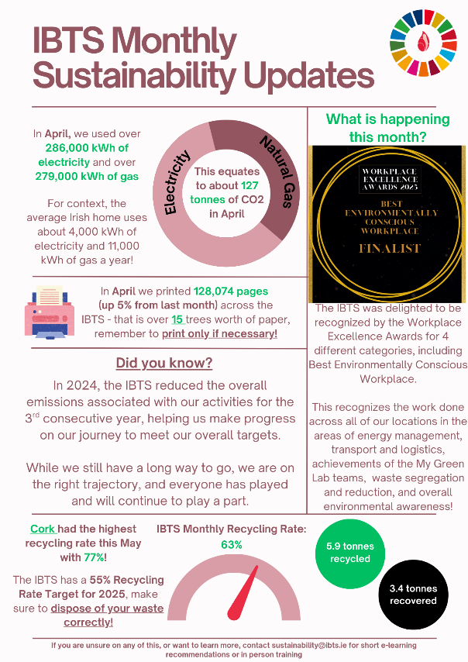
3.03 Training & Awareness
Figure 10 – An example of the monthly update provided by the Climate and Sustainability Lead for all staff.
3.03.01 Induction Slides
As previously noted under Our People, the Climate and Sustainability Lead has developed a Sustainability Module which all new joiners must receive and sign off on attendance and awareness of, which goes in tandem with the eLearning bespoke Sustainability at the IBTS module.
3.03.02 Internal Sustainability Awareness
In line with the previously mentioned monthly updates across the IBTS, awareness of statistics such as impacts of a particular building are key to help staff understand that they play a role in managing energy and environmental impacts of the IBTS.
As such we have begun to provide monthly and quarterly updates on topics such as waste streams, printing data, and energy use, to encourage staff to increase their own awareness and maybe take a lead within their roles or highlight issues that may not have been previously noted to the Facilities Team, the Climate & Sustainability Lead, or the Sustainability Steering Group.
This information is shared with all staff in the IBTS in our monthly staff newsletter Credit to the Crew, as seen in Fig. 10.
3.03.03 Sustainability Workshop Training
As part of the goal of increasing staff awareness of Sustainability and Climate initiatives and impacts, the IBTS organised for our waste contractor to host a large Sustainability Workshop in the National Blood Centre in October 2024, with over 50 staff attending in person and virtually. This provided staff the education on what the impacts of waste was, how to tackle the challenges, and how the waste is used in the downstream environment.
In 2025, a similar workshop will be held in Q4 2025 and will focus on aspects directly related to activities of the IBTS and will include more of a 2-way interactive process, encouraging dialogue on the opportunities for the organization.
We will continue to develop repeated Sustainability and Climate Awareness programmes, with a particular focus on workshops and other interactive initiatives as they really bring to focus the impact that staff can have both in the workplace and at home.
3.04 Construction
Any future developments within the IBTS Building Estate will include the use of Low Carbon Cement, where available, as directed by the Climate Action Mandate.
The IBTS will also comply with best practice guidelines for the preparation of Resource and Waste Management Plans for construction and demolition projects for directly procured or supported construction projects. This will also include assessments for the circularity of construction, ensuring that where possible, recycled materials will be included in the development of projects.
One such project highlighted in our pipeline is the new building that will be developed in Cork, the Facilities department have already discussed the requirements with the project team and highlighted the requirements and obligations the IBTS must meet as a public sector organisation. This will be an ongoing process over the next 4/5 years, and the ambition is to adhere to the best practice guidance laid out in the SEAI’s Public Sector guidance.
3.05 Homeworking
Where possible, depending on job role and responsibilities, IBTS encourages a flexible remote working environment, which encourages staff to have a healthy work-life balance, and will take some of the energy usage out of the National Blood Centre building IBTS buildings and have it relocated to staff homeworking set-ups.
This is supported by an internal policy, so staff are aware of their option to work remotely, where available.
3.06 Projects
There are several ongoing and upcoming projects and changes to the BAU working scenario across the IBTS, including the management of product generated, the storage of supplies after the product is produced and processed, and the transport of product. An example of this was the previously highlighted plasma production now underway in the IBTS at the NBC. This resulted in increased electricity use and along with additional projects, these will be assessed and scoped to ensure that the energy and environmental impacts of projects are understood when implementing and incorporated in long term planning for our targets.
3.07 My Green Labs (MGL)
Recognised by the United Nations Race to Zero campaign as a key measure of progress towards a zero-carbon future, My Green Lab (MGL) Certification is considered the gold standard for laboratory sustainability best practices around the world. As the IBTS represents excellence in our field, being exemplar in terms of our commitment to sustainable science, while continuing to provide our vital services, is of huge importance to us.
The National Donor Screening Laboratory (NDSL) at the NBC engaged with MGL in 2021 with the aim of educating & engaging IBTS laboratory staff on laboratory sustainability best practice to actively contribute to minimising the environmental impact of their lab operations and thereby assist the IBTS in meeting our 2030 Climate Action Plan targets of improving energy efficiency and reducing carbon emissions.
The Tissue Department, Scientific Support and Component Development Laboratory, Red Cell Immunohaematology Laboratory, NBC & Cork Quality Control Laboratory, Molecular Biology and Genetics Department developed action plans for their labs to meet the MGL sustainability targets and in December 2024 the Irish Blood Transfusion Service Labs became MGL Certified. Three of the labs achieved Green Certification, the highest level of accreditation offered by the programme.
We are committed to continual improvement of our systems within the organisation and reaching the highest certification possible.
3.08 Resource Management
3.08.01 Waste Management
- New Waste Management Plan
Collaborating with our waste services provider, Panda, the IBTS has created a new waste management strategy, across all buildings to provide the 3 core streams of waste (general, mixed recycling, and organic waste) bins. Where possible and needed, additional waste services are provided to maximize the segregation of waste to ensure the disposal is refined and having the least environmental impact.
This was hugely successful beginning in 2024, as we saw a big shift in correct segregation of waste with the recycling rates from January-August 2024 at 51% and in the 9 months following the change the rates improved to 58% on average. Our next steps are targeting specific waste streams that we believe can be minimised the production and utilise Extended Producer Responsibility (EPR) for specific streams.
- Waste Register
In line with the new waste strategy mentioned above, the Climate and Sustainability Lead will manage a Waste Register for all IBTS sites, allowing for assessment of trends in waste production. The waste register will record the 3 core streams, along with bulky wastes, WEEE, cardboard, battery recycling, hazardous clinical waste, grease trap waste, used cooking oil, and glass, along with the new streams for increased correct recycling. The European Waste Code (EWC), destination facility, and disposal methods are all retained.
This was important for the IBTS in 2025, as we had increased insight into our waste production, and our organisation was selected for an ad-hoc Waste Generation Survey by the Central Statistics Office, and we were able to be able to give highly accurate information with only some minor data gaps.
- Food Waste
With the introduction of the new waste management strategy, greater awareness of the impact of food waste regarding the upstream and downstream impacts of the production and disposal of food is shared with IBTS staff. As part of the sustainability induction slides, staff are informed of these risks if improperly managed, and made aware that if food waste is produced, it must be segregated correctly.
In Q3 2024, a new catering contract was granted to the canteen service provider at the National Blood Centre. Included in the arrangements were practices decreasing food waste and work with the IBTS to provide innovative practices to do this. We are currently assessing our options regarding implementing food waste donations with an additional 3rd party provider that will be able to feedback information on donations.
The Waste Register developed in house will allow the tracking of food waste production. There is a Canteen Focus Group, which the Climate and Sustainability Lead sits on, and this group will work to manage strategies to reduce food waste, highlighting events such as National Food Waste Awareness Day.
With the new Waste Register, after a full year of data has been collected as a baseline, we will establish food waste reduction targets, and the Sustainability Steering Group will lead the efforts for outreach to manage this reduction and assist with innovative approaches to waste re-use.
This will also assist with any waste reporting requirements for the organization, and for the sharing of data with the staff to ensure that impacts of waste are openly shared and brought to the focus of the IBTS. Many projects to manage waste impacts will be developed and piloted by the local Green Teams.
- Deposit Return Scheme (DRS)
The Deposit Return Scheme was an important next step for the IBTS to manage, as we sell these items in our canteen, but also provide them for free to all donors who attend our fixed and mobile clinics. As such, a large volume of these items is paid for to be provided by donors, with additional potential generation in the NBC canteen set up for sale to staff.
The NBC, along with our fixed clinics in D’Olier Street and Stillorgan began to collect the DRS items generated and donate these to the Re-Turn for Children scheme, donating directly to the 6 largest Irish Children’s Charities. This was an immediate success, with over €2,000 donated within the first 8 months. Many of our other centres/clinics have their own charity partners also at the local level for these donations.
In August 2025, the IBTS also agreed with Feed Cork to donate our DRS items from IBTS Cork to this local charity, operating in the same manner as Re-Turn for Children, the IBTS will retain the items, and the partner will collect and use the funds to support the charities work.
- Single Use Items
Working with our catering partners, the Facilities Department and the Climate and Sustainability Lead are assessing opportunities to remove Single Use Plastics from the canteen where possible. To date, single use coffee sachets have been removed, along with almost all sold plastic bottles in the canteen which were replaced by cans and cartons.
We are working on the strategy to remove disposable coffee cups and other disposables, and sauce sachets where possible. We are assessing our options to provide staff with re-usable water bottles and coffee cups to facilitate this change.
This will be an on-going project developed through engagement between the catering contractor, canteen group, and Sustainability Steering Group.
- Waste from Electric and Electronic Waste (WEEE)
Greater awareness of the requirement for segregation of Waste from Electric and Electronic Waste (WEEE) from ordinary waste streams is shared with staff. Working with WEEE Ireland, the IBTS will provide boxes for the collection and storage of batteries and disposable vapes (in line with new allowances) and inform staff of their obligations to use the correct disposal methods.
This will also assist the IBTS during the LED lighting upgrade, as WEEE Ireland allow for the disposal of fluorescent lighting systems through their own collection system, with the correct final disposal method, EWC code, and disposal location.
- Extended Producer Responsibility (EPR)
The IBTS is currently developing an update to the process for procurement to ensure that where a tender concerns one of the categories involved in the EPR scheme, requirements will be expected from the supplier to manage the waste and ensure that it is done in an efficient and most cost-effective manner.
This is especially prevalent when concerning WEEE items, of which the IBTS regularly upgrades in line with the most modern equipment available, and as such EPR would be vital.
3.08.02 Organic Food
During the most recent canteen tender, the IBTS incorporated best practice guidelines that were current at that stage for organic food procurement. In any future tenders, we will update with the most current best practice, utilising the Mandate guidance and the EPA GPP criteria.
3.08.03 ICT Equipment
The IBTS will continue to support GPP practices and the new guidance from the CAM regarding ICT will also be adopted as part of our future planning. It is noted that for much of our equipment, they already meet the TCO₂ requirement and have this marked on the items.
3.08.04 Water Management
- Drinking Water: The IBTS has put resources in place in our main facility at the National Blood Centre and many of our other locations to provide refillable drinking water stations to staff and in areas open to the public.
- We are currently liaising with the Extended Producer Responsibility model to assess opportunities for funding for additional drinking water refill sites. We will continue to take steps to increase this availability in our other locations to minimize any single use items available and encourage the use of sustainable replacements.
- Water Stewardship: The Climate and Sustainability Lead in 2026 will attend Uisce Éireann’s Water Stewardship course to be able to find innovative solutions to water management issues within the IBTS.
- Water Metering: Following on from the Climate and Sustainability Lead undertaking the Irish Water Stewardship Training Programme, it has been discussed about the feasibility of introducing water monitors in tandem with the energy monitoring system installed at NBC.
3.08.05 Paper Management
- Printing Practices: The IBTS has made major strides in the reduction of printing, especially since the outset of the COVID-19 Pandemic. At the time, our stores, purchasing, procurement and finance project approval processes moved to online approvals, and we have maintained that in place.
  - We are in the process of assessing the potential to further digitize our processes in the donor facing roles, by developing digital forms and record retention from the initial donor assessment within the IBTS, rather than the focus on the first form being submitted in paper format.
  - The printers within the IBTS are set up to scan to e-mail, and pull print is engaged, encouraging a focus on digital document storage and sharing, and discouraging unnecessary printing.
  - The IBTS currently uses paper that carries the European Ecolabel and is ECF Certified. We will continue to assess opportunities to increase level of recycled paper that we will be including in our organisation.
- Printing Data Register: To encourage additional reductions of printing through sharing of information and general awareness availability to staff, the Climate and Sustainability Lead has developed a printing data register, working with the printing contractor Ergo.
  - The Climate and Sustainability Lead will use this register to measure and monitor paper consumption and track changes. This will allow for planning and consolidation of printer usage, where possible. This will be shared in monthly/quarterly updates to encourage staff to rethink their printing practices when it is not essential.
  - To assist the IBTS in assessing performance in terms of reduced paper consumption, we have set a baseline for usage to be tracked against current progress. This was set at a pre-COVID 2019 baseline to show a fully office based BAU and to see the performance we can make against this. In Q4 2025 the IBTS will aim to set a target to further reduce this.

Section 4: Our Buildings and our Vehicles
4.01 Our Buildings
4.01.01 (Building Energy Rating) BER/Display Energy Certificate (DEC) Certs
We own our two largest buildings in Dublin and Cork, with the remaining six being leased. We will display an up-to-date Display Energy Certificate in the National Blood Centre. The Energy Audit conducted by EnerJ provided an update on the previous DEC and this is displayed in the entrance to the building. Additionally, our sites in Cork, D’Olier Street (Dublin), and Stillorgan (Dublin), are also over 250m² and open to the public, as such under the SEAI DEC Methodology, these would require certification.
These were procured in April 2025 for the 6 buildings (Cork was broken up into 3 separate buildings) and sent to the centres to be publicly displayed and will be refreshed upon expiry in 2026.
4.01.02 Energy Performance of Buildings Directive (EPBD)
The public sector was tasked to not install heating systems that use fossil fuels after 2023 for any new buildings and any major renovations retrofits. This is outlined in the EPBD, and there are several exclusions.
Due to the nature of the organisation, specifically the operations that occur in the National Blood Centre, the IBTS will be required to install a fossil fuel heating system. As outlined in the projects section of this Roadmap, the IBTS will install new energy efficient boilers to replace the current boilers which are at end-of-life and are at risk of failure.
This does comply with the exclusions listed in the EPBD, which allows for the installation of a heating system where there are “no technically viable non-fossil alternative” and that “the direct replacement of existing fossil fuel heating is required for an emergency maintenance purpose”.
4.01.03 Building Management (Exits & Nearly Zero Energy Building (NZEB))
The IBTS is currently assessing an opportunity to develop a new site to replace our current location in Cork, as outlined in the projects scoped for inclusion in the project pipeline. Any future changes from this project or another development would be in accordance with the NZEB standard, resulting in major energy performance improvement. Where it is not possible to have zero energy reliance, to have in place significant renewable energy facilities available.
Any future projects for the IBTS will continue to support the requirements highlighted within the CAM regarding sustainable construction methods and appropriate wase management for construction and demolition.
4.01.04 Internal Sub-Metering System
The IBTS has several sub-meters set up within the NBC that the Climate and Sustainability Lead will use to monitor performance in energy use and management when any system changes are implemented.
This metering was done at a high-level view, with some clamp assessments conducted on the smaller unit fridges and freezers required for the storage of the manufactured blood products. Understanding the energy demand of these systems will allow us to make informed decisions about optimising storage space and planning for future change.
The Climate and Sustainability Lead has undertaken Energy Metering training in September 2024, organized by the SEAI, which will allow for meaningful data gathering. This assists with the informed decision making of the Facilities department and the Climate and Sustainability Lead to replace inefficient equipment and overall optimize the management of energy use within the IBTS.
Based on the assessment of the Energy Auditing team at the National Blood Centre, it was advised that the IBTS invest in further submetering at a granular level to be able to provide detailed insights into equipment energy usage and be able to project and map impacts of additional equipment introduction.
4.01.05 Procurement of Energy-Related Products, Heating Equipment, Indoor, and Outdoor Lighting
In line with the requirements listed in the Climate Action Plan and best practice guidance, the IBTS will comply with SI 626 of 2016 related to the use of the Triple E register. We will also seek to utilise GPP guidance as previously stated to ensure that we are incorporating both the economically and the most sustainable option as part of the development of major projects.
This will encompass both the upstream and downstream impacts and we will ensure that the end-of-life of any equipment is assessed as part of the replacement and maximise repair, reuse, and recycling where applicable.
4.01.06 Procurement of Cleaning Contracts
In line with guidance and best practice, the IBTS will continue to utilise the EPA’s GPP guidance search criteria, specific for cleaning contracts. There is a tender in 2025 specifically for this contract and we are in the process of incorporating the relevant guidance from this to be used as a determining factor in the tender.
4.01.07 Existing Buildings
While the Building Stock Plan (BSP) was not previously developed for the IBTS, this has been completed for the Stage 1 BSP, and submitted to the SEAI in Q3 2025, which is included as Appendix Item 4.
This will be updated every 2 years at a minimum, and the IBTS will also move onto the Stage 2 BSP as this will be a helpful tool for use during the development of our project pipeline.
4.02 Our Vehicles
4.02.01 Clean Vehicles Directive (SI 381/2021)
The vehicles procured by the IBTS in the period since the introduction of the Clean Vehicles Directive, have been done so with a view for the onboarding of HVO 100 as a fuel source when this is fully available commercially.
Our current fuel provider has a contract in place with the IBTS to provide this and once available, it will be the standard practice for the use of HVO 100 in all fleet vehicles, which would follow the Clean Vehicles Directive. This is projected to be fully implemented by 2027, as indicated in the project pipeline for the IBTS.
4.02.02 Management of Business Mileage
The IBTS operates sites nationwide, and due to the nature of our services, requires extensive travel between locations, including trips to conferences and to mobile clinics. It is the policy of the IBTS to use public transport links as a first option, with the use of private motor vehicles reserved only for routes that do not have the option for public transport, as such keeping the business mileage assigned to the most sustainable options available.
Due to increased restrictions during the COVID pandemic, the IBTS was heavily reliant on private motor vehicles for this travel. As these have now phased out, robust policies have encouraged staff to opt for public/commercial travel where possible. As can be seen in Fig. 11 this has resulted in the successful change in the share of business mileage within the organisation, with a much higher percentage of public transport now utilised by our staff.
Additional requirements are adhered to when any flights are concerned, with a revised conference attendance policy promoting virtual attendance opportunities ahead of travel approval.

Figure 11 – Change in business mileage share from IBTS staff in the post-COVID shift, assisted by the development of robust policy.
4.02.03 Installation of Charging Infrastructure
We have invested in EV charging in our main Dublin facility which has the capacity to charge any corporate vehicles which we would procure in the future, as well as charging cars belonging to staff and blood donors (both on a paid basis).
This would be the only site that the IBTS has a specific car park for our staff that we would have operational control of, however if these circumstances change in the future, we will review opportunities to expand the EV infrastructure.
4.02.04 Compliance with Circular 01/2020
Since its inception in 2020, the IBTS has followed Circular 01/2020, requiring Public Bodies to declare the official air travel usage and to make a payment to offset the carbon emissions valuation to the Climate Action Fund the following year.
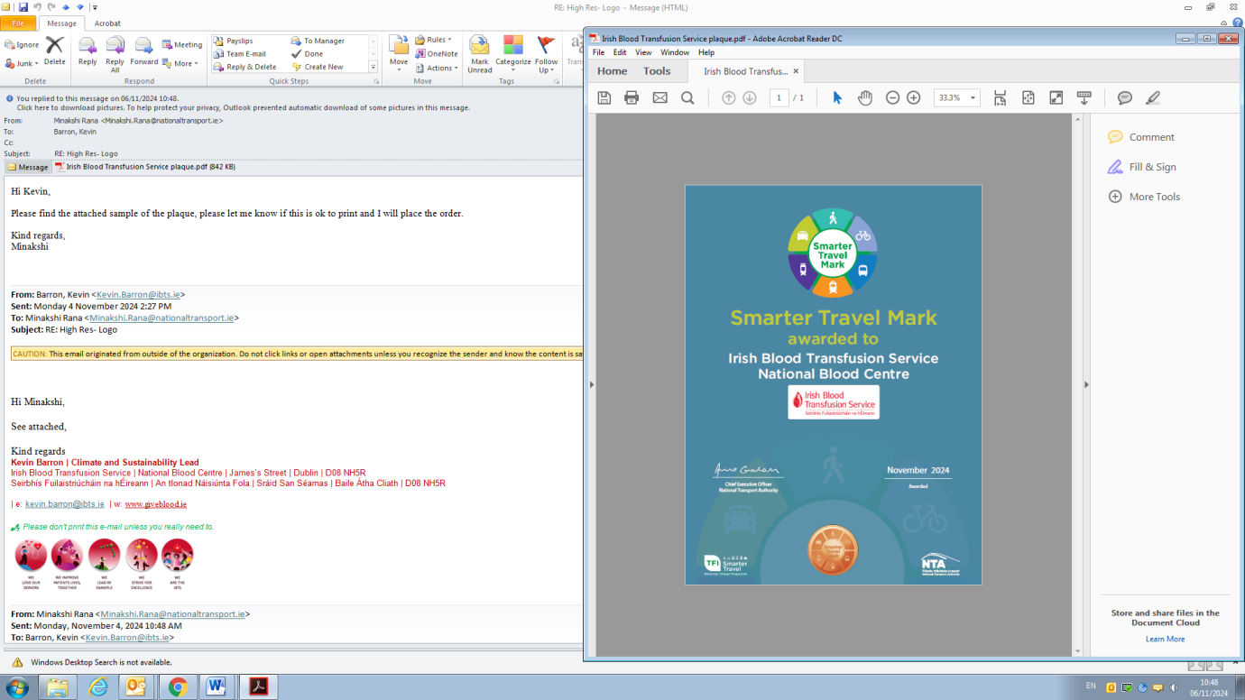
4.02.05 Smarter Travel Mark & Programme
Figure 12 - The IBTS Bronze Smarter Travel Mark Award for the National Blood Centre
The IBTS successfully completed the application and audit process for the National Transport Authority Smarter Travel Mark, and we were delighted to receive the Bronze Level Mark, which provides us a basis for the project to be further improved at the National Blood Centre and expanded to our other locations.
We have conducted a Commuting Survey in 2024, with a follow up survey planned for Q4 2025, this will allow us to track progress in commuting changes over the coming years and inform the IBTS on the requirements and considerations for staff regarding commuting.
We intend to utilise the promotional materials available within the NTA’s Smarter Travel Programme and encourage our staff to take part in these activities. We are finalising some details with the NTA before this can hopefully be approved for Q4 2025.
4.02.06 Sustainable Commuting
- Staff can access Taxsaver Leap Cards paid for directly from their payslips, saving money for the staff and encouraging them to choose a more sustainable transport option for their commute.
- The IBTS is a keen supporter of the Cycle to Work Scheme and has promoted the scheme regularly within the workforce. This allows for staff to use an emissions free transport method to access their work location and is a healthy form of exercise. Between 2014 and mid-2025, 229 staff members engaged with the scheme, aided by the exclusive and secure IBTS locked bike storage and on-site shower facilities for staff at the NBC, and some other locking facilities at most of our other sites.
  - We are assessing opportunities to further expand the programme in line with the Smarter Travel Programme and avail of the support as a partner of the programme.
4.02.07 Car Park Funds Generation
As previously mentioned, IBTS staff are encouraged to consider sustainable commuting options where possible. To encourage these decisions, a new IBTS car parking policy was introduced for the NBC. In line with the Climate Action Plan 2024, which encourages public sector bodies to achieve a 20% reduction in commuting private car kilometres, the IBTS currently has a paid parking permit scheme. This internal levy was doubled in 2025 and will discourage individual private car kilometres.
To further enhance the positive impact of this scheme future increases when sanctioned may be partially assigned to a sustainability fund, allowing for activities, workshops, or other programmes to be developed for the NBC.
We have currently not developed plans to phase out parking at the NBC (the only applicable building as in all other buildings we do not have any parking or no guaranteed parking), however we will continue to assess this.
Conclusion
The IBTS has made major strides towards achieving the 2030 targets set for the organisation by the Climate Action Mandate. We are confident in the robustness of our Climate Action Roadmap in providing a framework for the IBTS to meet our carbon reduction targets and to improve overall energy efficiency within the organisation.
Much of the success in meeting these targets will be through the successful implementation of facilities projects to manage energy usage in the National Blood Centre, and through management of fuel usage and specifically the fuel involved in the IBTS fleet.
These projects will incur a significant outlay for the IBTS, which shows the firm commitment to act as a leader within the Public Service Organisations to help to achieve the Public Sector Climate Action Mandate.
The IBTS will continue to investigate additional potential opportunities to improve energy efficiency and reduce our emissions and will comply with any future changes for the Climate Action Mandate and are committed to updating our Roadmap to reflect this, as required.
The implementation of the facilities projects will be the first step in the success however, as we are reliant on our staff and our donors to help to meet our broader ESG goals, as highlighted in this document. We would like to thank our staff and our donors for their continued support of the IBTS and the significant task at hand we have of fully implementing this Climate Action Roadmap and ensuring the long-term success of the IBTS is managed in the most sustainable manner possible.

Appendix
Item 1: Register of Opportunities from EnerJ Audit Report
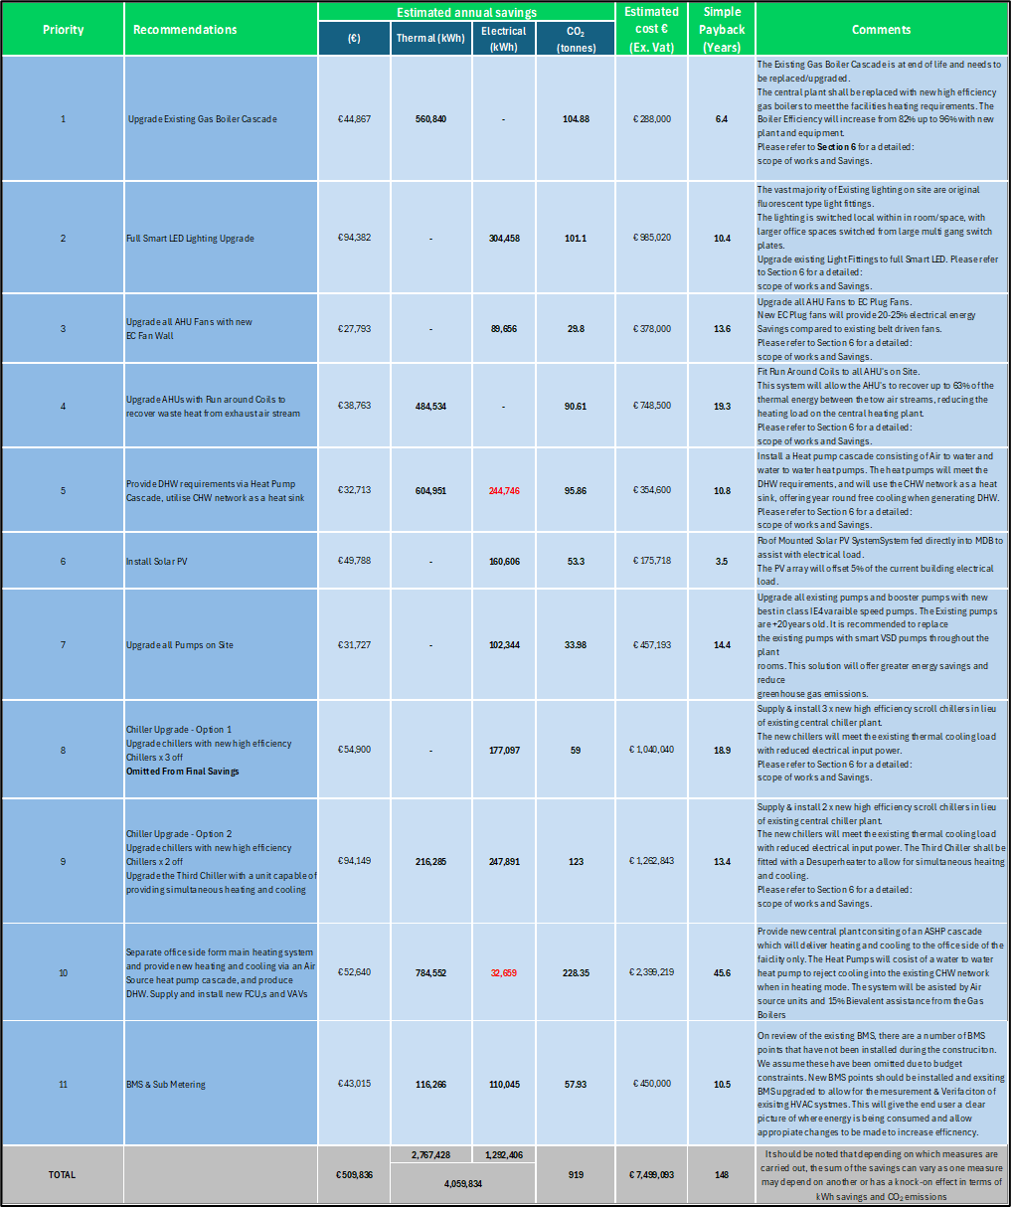
Item 2: Governance Structure for Climate Action Roadmap in the IBTS
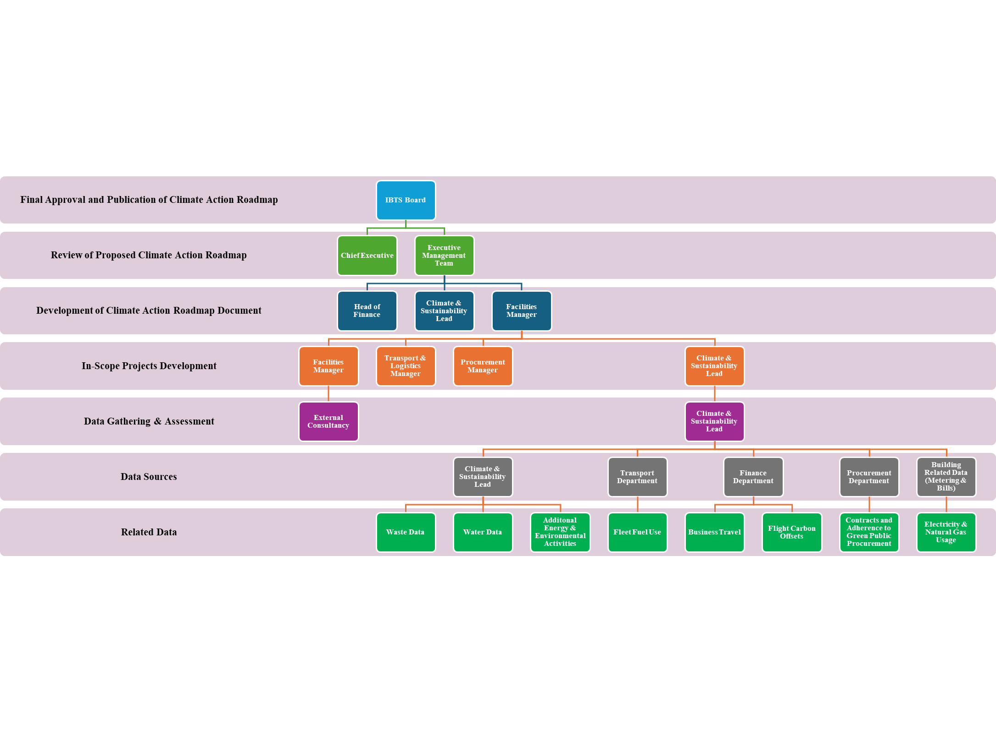
Appendix Item 1 - Governance Structure for the Development and Publication of the Climate Action Roadmap.
Appendix Item 3: Sustainability Steering Group TOR
Sustainability Steering Group Terms of Reference

Sustainability Steering Group Membership
The following staff members are members of the SSG:
Name | Job Title | Role in SSG
Kevin Barron | Climate and Sustainability Lead | Chair
Graham Healy | Facilities Manager | Co-Chair
Greta Domarkaite | Senior Medical Scientist | Member
Fiona Young | Senior Medical Scientist | Member
Padraig Williams | Head of Testing | Member
Caroline Casey | Medical Scientist | Member
Brian Boland | Procurement Manager | Member
John Gately | Transport and Logistics Manager | Member
Simone Farrell | Data Protection Team | Member
Qumar Jahan | Clinical Nurse Manager 3 | Member
Judy Moloney | Clerical Officer; Accounts Payable / Receivable | Member
Moira Keogh | Chief Medical Scientist | Member
Aileen Farrelly | Chief Medical Scientist | Member
Ellen Van Looy | Learning & Development Manager | Member
Karen Wilkinson | Clerical Officer; Finance (Cork) | Member
Iosif Korpas | Area Manager (Ardee) | Member
Appendix Item 3 - Table containing the members of the Sustainability Steering Group, their IBTS role, and the role within the SSG.

SSG Responsibilities
The SSG general sustainability responsibilities are as follows:
- Assisting in the success of the improvement of Sustainability aspects across the organisation of the IBTS by providing guidance and insight to the Climate and Sustainability Lead and the Facilities Manager.
- Reporting to the Senior Leadership Team (via the Climate and Sustainability Champion) on sustainability, energy, and climate action.
- Providing insight for the development and implementation of the IBTS Climate Action Roadmap and the IBTS Sustainability Strategy.
- Assessing needs and expectations of stakeholders.
- Raising queries and suggestions from staff and externals regarding energy, environmental, and wholistic sustainability impacts of the IBTS.
- Assisting with guidance on legal and policy requirements implementation.
- Assisting the Climate and Sustainability Lead and the Facilities Manager with identifying and addressing risks to achieving energy and climate targets.
- Identifying projects to achieve energy and climate targets.
- Identifying behavioural improvements to achieve energy and climate targets.
- Developing actions plans for and implementing energy and climate projects and measures.
- Assisting with the provision of necessary resources (people, skills, training, financial, equipment, time) are in place to deliver on engagement and projects, where appropriate for the involvement of the SSG.
- Delivering sustainability, climate, and energy staff engagement workshops.
- Ensuring relevant training needs are identified and met.
- Attending monthly SSG meetings.

SSG Meetings
The SSG (from 2025) meets a minimum of ten times per annum. Meetings are held on the third Thursday of every month, with the possibility of additional meetings in July and December depending on annual leave. Meetings are chaired by the Climate and Sustainability Lead and minuted. These minutes are circulated to the team after each meeting and, if relevant, sent to the Climate and Sustainability Champion (Director of Finance). Each meeting is scheduled for one hour. The typical agenda is as follows:
- Review of minutes and actions from last meeting.
- Review of organisational energy performance for the month.
- Review of Action Plans for planned or in progress projects and initiatives.
- Discussion of any other items relating to responsibilities

Appendix Item 4: IBTS Stage 1 Building Stock Plan

Appendix Item 5: IBTS Sustainability Strategy
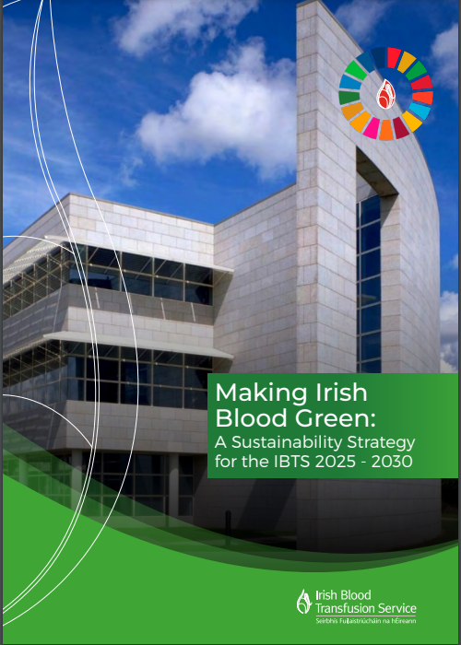

SEAI Public Sector Annual Report 2023. Last available annual report for review.
Section 15(1) of the Climate Action and Low Carbon Act.
Values in this figure are rounded to the nearest whole tonne of CO₂eq.
Values in this statement are rounded for simplification.
Values in this figure are rounded to the nearest whole %.
Values in this statement are rounded for simplification.
Values in this statement are rounded for simplification.
Irish Climate Statement 2024 – Met Éireann
Report on biodiesel use in forecourt diesel blend.
Values in this statement are rounded for simplification.
Government of Ireland Renewable Transport Fuel Policy 2023-2025
Government declaration on renewable transport fuels in Ireland 2022
European Commission Regulatory Framework targeting efficiency upgrades in the use of fans/motors in the European Union.
European Commissions Publication on the thermal efficiency minimum criteria for Heat Recovery Systems
My Green Labs: https://www.mygreenlab.org/
Codex Standard Office Paper which is certified ECF.
Nearly Zero Energy Buildings – Standard information SEAI
Circular 01/2020 Procedures for Offsetting the Emissions Associated with Official Air Travel
Climate Action Plan 2024 – Sub-Targets to deliver abatements in Transport

